**EXPERIMENT 3**

**Aim :**

**(a)** To determine the type of Triangle. Its input is triple of positive integers (say a, b, c) and values may be from the interval [1, 100]. The output may have one of the following :

Equilateral, Isosceles, Scalene or Not a Triangle.

Perform Boundary Value Analysis and show the Test Cases.

**Algorithm :**

* Take 3 inputs from the user for the sides of the Triangle.
* Check whether they lie in the given interval.
* If the condition is false, stop the program and exit.
* If the condition is true, check the type of Triangle.
* If all three sides are equal, Equilateral Triangle.
* If any two sides are equal, Isosceles Triangle.
* If all three sides are different, Scalene Triangle
* According to the formula ***4 n + 1,*** there will be ***13*** test cases, where n is number of inputs.

**Code :**

#include <iostream>

using namespace std;

void bva(int, int, int);

int main()

{

    int min, max;

    int x, y, z;

    cout << "Enter Range : ";

    cin >> min >> max;

    if (min < 0 || max > 100)

    {

        cout << "Invalid Range";

        return 0;

    }

    int nominal = (min + max) / 2;

    int values[] = {min, min + 1, nominal, max - 1, max};

    cout << "a\tb\tc\tOutput" << endl;

    for (int i = 0; i < 5; i++)

    {

        bva(values[i], nominal, nominal);

    }

    for (int i = 0; i < 5; i++)

    {

        if (values[i] != nominal)

            bva(nominal, values[i], nominal);

    }

    for (int i = 0; i < 5; i++)

    {

        if (values[i] != nominal)

            bva(nominal, nominal, values[i]);

    }

    cout << "Enter the Sides of Triangle (a, b, c) : ";

    cin >> x >> y >> z;

    cout << "a\tb\tc\tOutput" << endl;

    bva(x, y, z);

    return 0;

}

void bva(int a, int b, int c)

{

    cout << a << "\t" << b << "\t" << c << "\t";

    if (a < 1 || a > 100 || b < 1 || b > 100 || c < 1 || c > 100)

        cout << "Invalid Range" << endl;

    else if ((a < b + c) && (b < a + c) && (c < a + b))

    {

        if ((a == b) && (b == c))

            cout << "Equilateral Triangle" << endl;

        else if ((a != b) && (b != c) && (c != a))

            cout << "Scalene Triangle" << endl;

        else

            cout << "Isosceles Triangle" << endl;

    }

    else

        cout << "Not a Triangle" << endl;

}

**Boundary Value Analysis :**

***Range :*** R [1, 100]

***Domain :*** Minimum = 1

Above Minimum = 2

Nominal = 50

Below Maximum = 99

Maximum = 100

**Output Screenshot :**

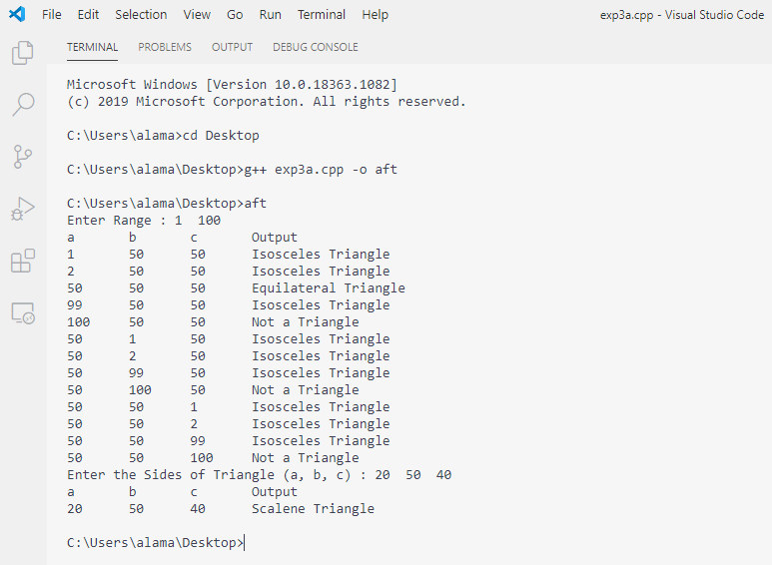

**Aim :**

**(b)** Write a program for classification of Triangle on the basis of angle. Its input is triple of positive integers (say a, b, c) and values may be from the interval [1, 100]. The output may have one of the following :

Right Angled, Acute Angled, Obtuse Angled or Not a Triangle.

Perform Boundary Value Analysis and show the Robust Test Cases.

**Algorithm :**

* Take 3 inputs from the user for the sides of the Triangle.
* Check whether they lie in the given interval.
* If the condition is false, stop the program and exit.
* If the condition is true, check the type of Triangle.
* If the square of one side is equal to the sum of squares of other two sides, Right Angled Triangle.
* Else if the square of one side is greater than the sum of squares of other two sides, Obtuse Angled.
* Else if the square of one side is less than the sum of squares of other two sides, Acute Angled.
* According to the formula ***4 n + 1,*** there will be ***13*** test cases, where n is number of inputs.
* Robust Test Cases ***= 6 n + 1 = 6 * 3 + 1 = 18 + 1 = 19.***

**Code :**

#include <iostream>

using namespace std;

void bva(int, int, int);

int main()

{

    int min, max;

    int x, y, z;

    cout << "Enter Range : ";

    cin >> min >> max;

    if (min < 0 || max > 100)

    {

        cout << "Invalid Range";

        return 0;

    }

    int nominal = (min + max) / 2;

    int values[] = {min, min + 1, nominal, max - 1, max};

    cout << "a\tb\tc\tOutput" << endl;

    for (int i = 0; i < 5; i++)

    {

        bva(values[i], nominal, nominal);

    }

    for (int i = 0; i < 5; i++)

    {

        if (values[i] != nominal)

            bva(nominal, values[i], nominal);

    }

    for (int i = 0; i < 5; i++)

    {

        if (values[i] != nominal)

            bva(nominal, nominal, values[i]);

    }

    cout << "Enter the Sides of Triangle (a, b, c) : ";

    cin >> x >> y >> z;

    cout << "a\tb\tc\tOutput" << endl;

    bva(x, y, z);

    return 0;

}

void bva(int a, int b, int c)

{

    cout << a << "\t" << b << "\t" << c << "\t";

    if (a < 1 || a > 100 || b < 1 || b > 100 || c < 1 || c > 100)

        cout << "Invalid Range" << endl;

    else if ((a < b + c) && (b < a + c) && (c < a + b))

    {

        if ((a * a == b * b + c * c) || (b * b == c * c + a * a)

|| (c * c == a * a + b * b))

            cout << "Right Angled Triangle" << endl;

        else if ((a * a > b * b + c * c) || (b * b > c * c + a * a)

|| (c * c > a * a + b * b))

            cout << "Obtuse Angled Triangle" << endl;

        else

            cout << "Acute Angled Triangle" << endl;

    }

    else

        cout << "Not a Triangle" << endl;

}

**Boundary Value Analysis :**

***Range :*** R [1, 100]

***Domain :*** Below Minimum = 0

Minimum = 1

Above Minimum = 2

Nominal = 50

Below Maximum = 99

Maximum = 100

Above Maximum = 101

**Output Screenshot :**

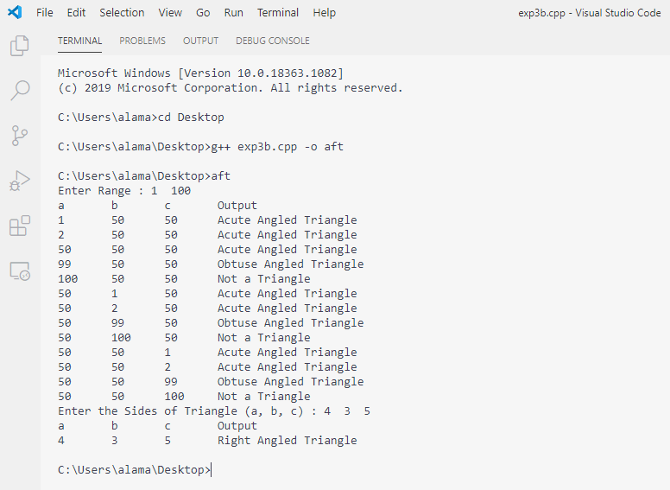

**Robust Test Cases :**

|  |  |  |  |  |
| --- | --- | --- | --- | --- |
| **Test Case** | **a** | **b** | **c** | **Expected Output** |
| 1 | 1 | 50 | 50 | Acute Angled Triangle |
| 2 | 2 | 50 | 50 | Acute Angled Triangle |
| 3 | 50 | 50 | 50 | Acute Angled Triangle |
| 4 | 99 | 50 | 50 | Obtuse Angled Triangle |
| 5 | 100 | 50 | 50 | Not a Triangle |
| 6 | 0 | 50 | 50 | Invalid Range |
| 7 | 101 | 50 | 50 | Invalid Range |
| 8 | 50 | 1 | 50 | Acute Angled Triangle |
| 9 | 50 | 2 | 50 | Acute Angled Triangle |
| 10 | 50 | 99 | 50 | Obtuse Angled Triangle |
| 11 | 50 | 100 | 50 | Not a Triangle |
| 12 | 50 | 0 | 50 | Invalid Range |
| 13 | 50 | 101 | 50 | Invalid Range |
| 14 | 50 | 50 | 1 | Acute Angled Triangle |
| 15 | 50 | 50 | 2 | Acute Angled Triangle |
| 16 | 50 | 50 | 99 | Obtuse Angled Triangle |
| 17 | 50 | 50 | 100 | Not a Triangle |
| 18 | 50 | 50 | 0 | Invalid Range |
| 19 | 50 | 50 | 101 | Invalid Range |